Feminine Rhyme Couplets

🎯 What is Feminine Rhyme Couplets
# Source: Chatgpt (GPT-4-turbo) at [8/2/2025]
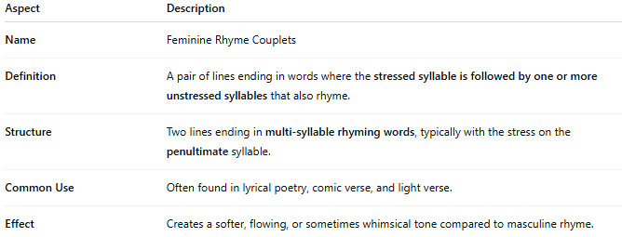
Aspect | Description
Name | Feminine Rhyme Couplets
Definition | A pair of lines ending in words where the stressed syllable is followed by one or more unstressed syllables that also rhyme.
Structure | Two lines ending in multi-syllable rhyming words, typically with the stress on the penultimate syllable.
Common Use | Often found in lyrical poetry, comic verse, and light verse.
Effect | Creates a softer, flowing, or sometimes whimsical tone compared to masculine rhyme.

✅ Example of Feminine Rhyme in a Couplet
# Source: Chatgpt (GPT-4-turbo) at [8/2/2025]
Her beauty shone in morning light
A vision pure, a true delight
Another clearer example:
She offered him a melody
He answered with a remedy
- "melody" / "remedy" are feminine rhymes:
  - stress on first syllable (mel- / rem-)
  - followed by unstressed syllables (-ody)

